**FPT ACADEMY INTERNATIONAL**



## FPT – APTECH COMPUTER EDUCATION

OrigamiForAll

|  |  |  |  |
| --- | --- | --- | --- |
| **Center Name** | | FPT – Aptech – HCM2  Address: 590 Cach Mang Thang Tam, District 3, Ho Chi Minh City | |
| **Instructor** |  | Ms. Le Mong Thuy |  |
| **Class** |  | T1.2002.E0 |  |
| **Group** |  | 6 |  |
| **Group members** | | **Name** | **Student ID** |
|  |  | Nguyen Anh Tuan | Student1261141 |
|  |  | Doan Nguyen Tuan Anh | Student1262131 |
|  |  | Nguyen Kim Hoang Nam | Student1241116 |
| **Duration** | Start date | 15th June 2020 |  |
| End date | 22nd July 2020 |  |

**This is to certify that**

**Mr:**

Nguyen Anh Tuan

Doan Nguyen Tuan Anh

Nguyen Kim Hoang Nam

**has successfully designed & developed**

eProject: OrigamiForAll website

**Submitted by:**

Nguyen Anh Tuan

**Date of issue:** July 22nd 2020

**Authorized Signature:**

# ACKNOWLEDGE

To have a successful project, it is the continuous effort of many people. The most important person is Ms. Le Mong Thuy – our teacher. With many years’ experience of teaching, along with enthusiasm as well as rigorous in guiding the project, she is the person who helped us complete the subject to catch the schedule can achieve our goal. Besides, this is the efforts and curiosity of the members in our group. We have focused on starting the project very early, promoting teamwork by sharing experiences and knowledge with each other throughout the project. The last but not least, we would like to say thank you to our family for always supporting us, creating the best conditions for us to focus on the project, and putting faith in the dreams we pursue.

# SYNOPSIS

Origami originated from China and was popularized in Japan. It is the art of paper folding. Paper-folding is a wonderful hobby and a wonderful group activity... and for kids it has so many benefits socially and for the developing mind. You get to make cool stuff - with only a sheet of paper!

Origami can range from the super complex with realistic models to the simple models that are more easy to fold, but yet very recognizable.

Here we are aiming to design a website “OrigamiForAll” which will provide an easy way to learn origami with various designs and steps involved.



**TABLE OF CONTENTS**

FPT – APTECH COMPUTER EDUCATION 1

PROBLEM DEFINITION 3

CUSTOMER'S REQUIREMENTS SPECIFICATIONS (CRS) 4

Business/Project Objective: 4

Hardware/ Software Requirements: 5

SCOPE OF THE WORK (IN BRIEF) 6

Architecture and design of the system 7

Diagram of the website 8

SITE MAP 10

MOCK OF THE WEBSITE 11

WEB DESCRIPTION…………………………………………………..…………………….18

1. Home page 19

2. About 20

3. Information 19

4. Models 23

5. News 24

6. Contact 26

# PROBLEM DEFINITION

The Web site is to be created based on the following requirements.

1) The home page must describe the keywords or highlight the origami designs

with all navigation links defined.

2) The site should provide the brief information about origami as from where it

originated etc.

3) There should be a well designed menu with necessary sub menu options.

4) There should be various categories (forms and styles) like easy for kids,

complex for elders.

5) There should also be categories of designs as Faces, animals, birds, flowers

etc. Minimum 10 categories are expected here.

6) Proper description of the design along with the image and steps must be

added in the website.

7) Contact Us.

8) About Us.

9) Feedback form.

10) Gallery section should be added.

11) Color combination must be uniform throughout the project.

12) Navigation must be smooth.

# CUSTOMER'S REQUIREMENTS SPECIFICATIONS (CRS)

**Client: *OrigamiForAll***

### Business/Project Objective:

OrigamiForAll is an organization to create a enviroment for learing how to fold Origami. They provide an easy way to learn Origami with various designs and steps involved.Beside, they give some information about Origami too.

We are supposed to create a website for them with the below mentioned requirement specifications.

The website is to be developed for the Windows Platform using HTML5, JavaScript and Geolocation. The site should work well in all leading browsers including Chrome, IE, Firefox etc.

**Input to the system:**

* + - * Searching Origami threats, Origami models with the guidance.
      * Searching information, documents which teaching Origami.
      * Feedback about our models problem or new models which you want to share.
      * Register members on website.

**Output from the system:**

* Displaying information of models that the user is looking for, including forms, styles, images, guidance.
* Display posts or links to some posts about Origami and contact details of Origami centers, Origami clubs.

**Process**:

* + - * Create Learning page
      * Validate data input from users.

**Expected delivery date:** 17-July-2020.

**List of deliverables:**

* + - * Document Word.
      * User Guide.
      * Source code.

### Hardware/ Software Requirements:

* **For web developer**

**Hardware**

* + Intel Pentium 4 processor or higher
  + 1 Gigabytes of RAM or higher

### Software

* + Windows 7 OS or higher
  + Adobe Dreamweaver
  + Web browsers such as IE, Chrome or Firefox are supporting HTML5, CSS3 and Javascript.

### For web users

**Hardware**

* + Intel Pentium 4 processor or higher
  + 512 Megabytes of RAM or higher

### Software

* + Windows XP OS or higher
  + Web browsers such as IE, Chrome or Firefox are supporting HTML5, CSS3 and Javascript.

# SCOPE OF THE WORK (IN BRIEF)

After a long and detailed discussion, our group has decided to create a website contain the following webpages:

1. ***Homepage***: Display information about Origami models.
2. ***Information***: Introduction about Origami and OrigamiForAll.
3. ***About***: Display the information of the club(OrigamiForAll).
4. ***News***: Allow user can find some documents like posts or videos to learn how to fold Origami from newbie level to master level.
5. ***Models:*** Display a catalogue of Origami according to their styles, forms.
6. ***Contact***: Display the address of the club, allow user to request any information they want to OrigamiForAll. Feedback of visitors to webmaster.

# Architecture and design of the system

Webpage request



Requested Page

**RENDERING**

**ENGINE**

**CSS CODE**

**HTML CODE**

**WEB SERVER**

**WEB BROWSER**

**CLIENT**

**SERVER**

# 

# Diagram of the website

|  |
| --- |
| HOME |
| INFORMATION |
| ABOUT US |
| NEWS |
| MODELS |
| CONTACT |

END

BEGIN





**TASK SHEET REVIEW 1**

|  |  |  |  |  |  |  |  |
| --- | --- | --- | --- | --- | --- | --- | --- |
| **Project Ref. No.:**  **eP/Advertisement Portal Management**  **System/01** | | **Project Title:** | **Activity Plan Prepared By:** | **Date of Preparation of Activity Plan:** | | | |
| **Sr.**  **No.** | **Task** | **Actual**  **Start Date** | **Actual Days** | **Team**  **Mate Names** | **Status** |
| 1 | Problem Statement | Origami  ForAll | Nguyen  Anh  Tuan | 15-Jun-20 | 1 | Nam | Completed |
| 2 | Analysis of OrigamiForAll requirements about the website | 15-Jun-20 | 1 | Nam | Completed |
| 3 | The scope of the work (in brief) | 15-Jun-20 | 1 | Nam | Completed |
| 4 | Architecture and design of the system | 15-Jun-20 | 1 | Nam | Completed |
| 5 | Diagram of the website | 15-Jun-20 | 1 | Nam | Completed |
| 6 | Task Sheet | 15-Jun-20 | 1 | Nam | Completed |

|  |  |
| --- | --- |
| **Date:** 15-June-2020 | |
| Signature of Instructor:  **Ms. Le Mong Thuy** | Signature of Team Leader:  **Mr.Nguyen Anh Tuan** |

# SITE MAP

**HOME PAGE**

**ABOUT**

**MENU**

**INFORMATION**

**MODELS**

**NEWS**

**LOG IN PAGE**

**LOG IN**

**CONTACT**

### Home page

# Mock of the website

**HEADER**

**LOGO - MENU**

**PICTURE SLIDESHOW**

**INFORMATION**

**ABOUT**

**MODELS**

**NEWS**

**CONTACT**





**TASK SHEET REVIEW 2**

|  |  |  |  |  |  |  |  |
| --- | --- | --- | --- | --- | --- | --- | --- |
| **Project Ref. No.:**  **eP/Advertisement**  **Portal Management System/01** | | **Project Title:** | **Activity Plan Prepared By:** | **Date of Preparation of Activity Plan:** | | | |
| **Sr.**  **No.** | **Task** | **Actual Start Date** | **Actual Days** | **Team Mate Names** | **Status** |
| 1 | Site map | OrigamiFor  All | Nguyen  Anh  Tuan | 23-Jun-20 | 1 | Tuan | Completed |
| 2 | Mock of the website | 23-Jun-20 | 1 | Tuan | Completed |
| 3 | Task sheet | 23-Jun-20 | 1 | Tuan | Completed |

|  |  |
| --- | --- |
| **Date:** | |
| Signature of Instructor:  **Ms. Le Mong Thuy** | Signature of Team Leader :  **Mr.Nguyen Anh Tuan** |

# WEBSITE DESCRIPTION

**HOMEPAGE**

**Description:**

This webpage displays following information: LOGO, Menu bar: home, information, about, models, news, contact, sologan and The chat bot of origami followings below.

**Screenshot:**

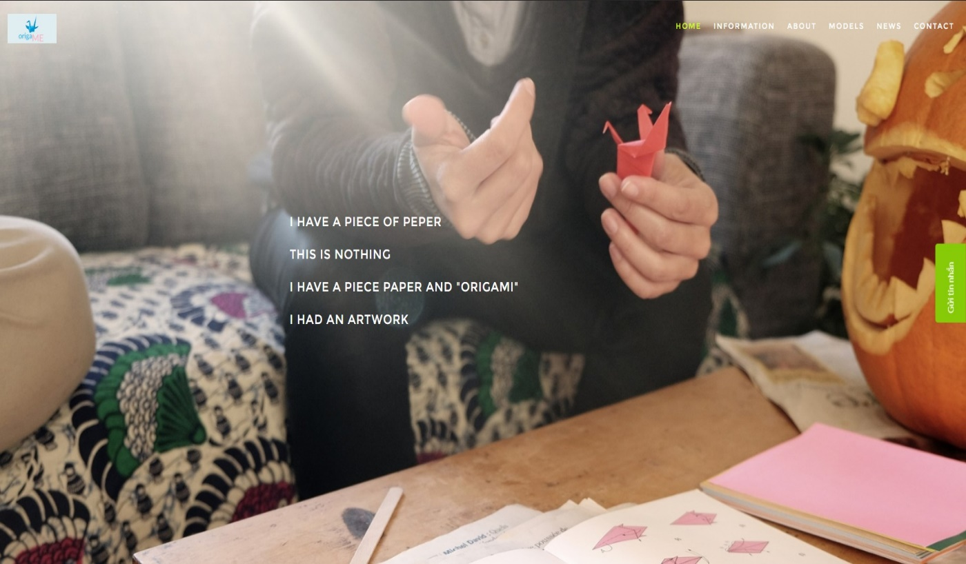

**INFORMATION**

**Description:**

There are some informations bellows in this task. It is including: introduction, original, techniques, symbolize, the importance of origami and most popular.

**Screenshot**

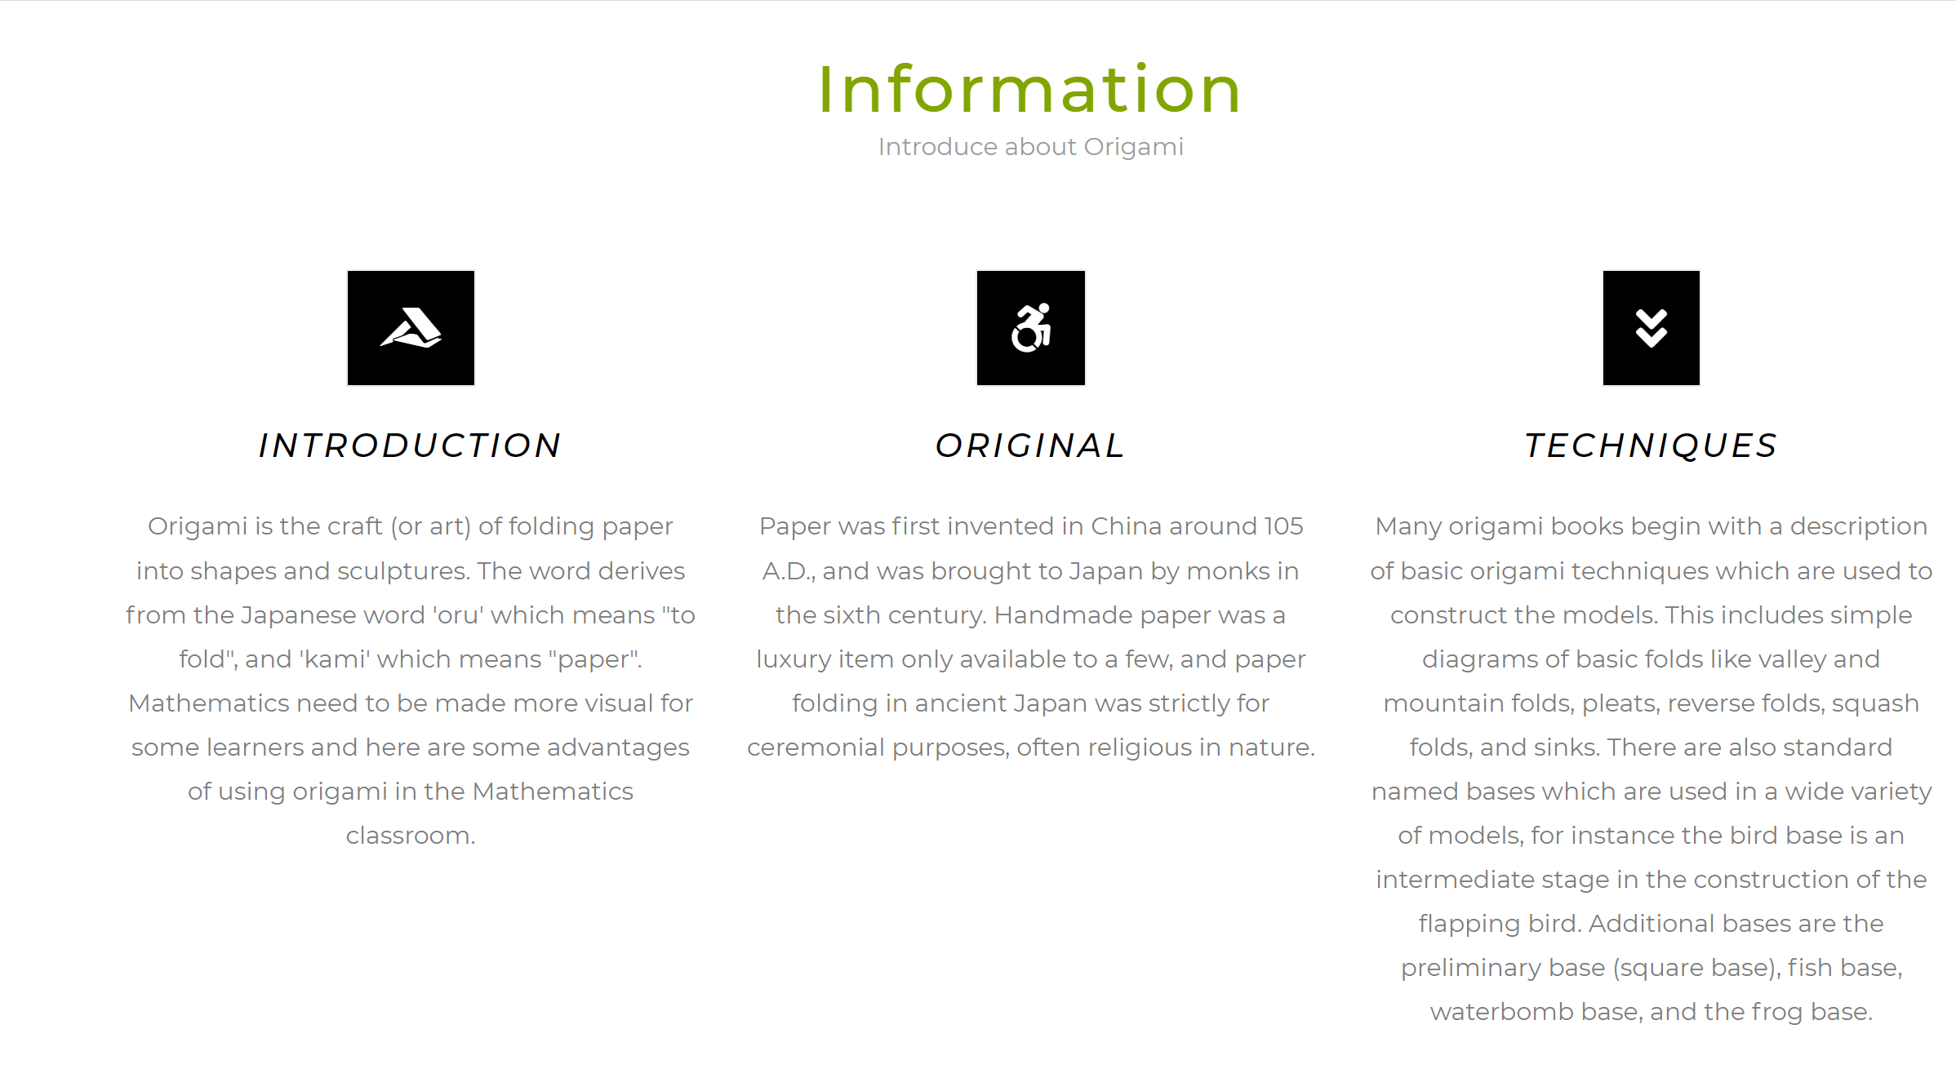

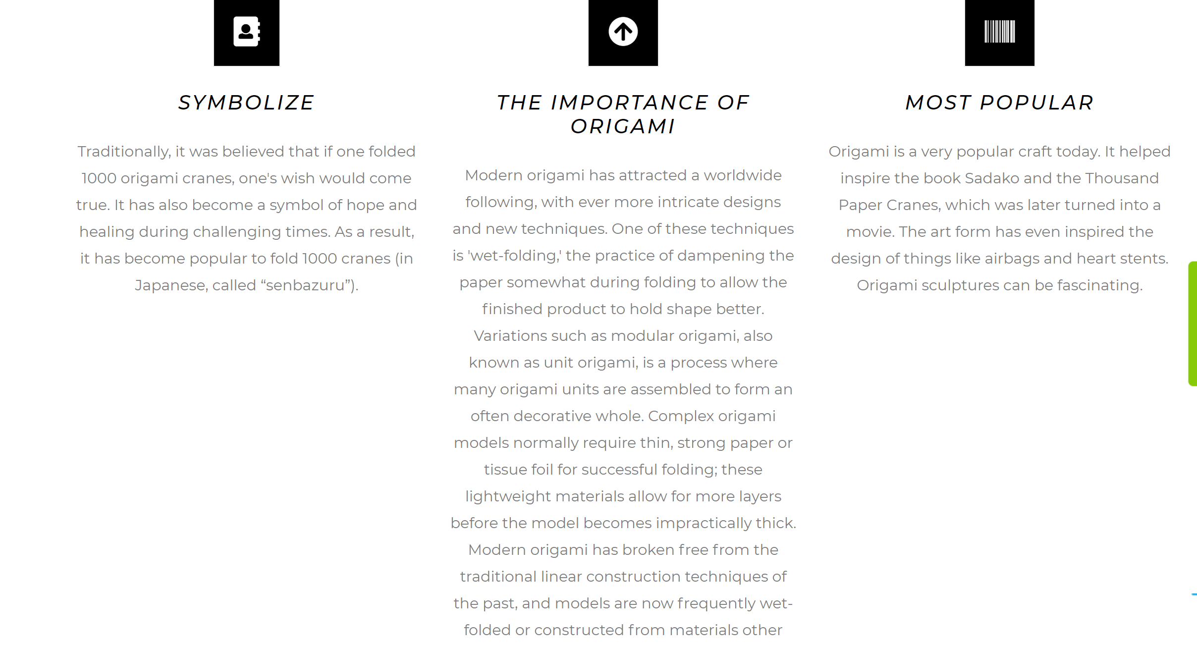

In this part, the users can know more about the details of information about art origami. They can demonstrate this kind of art – paper folding.

**ABOUT US**

**Description:**

About us we talked about the how to approach the problem, how to build and develop ideas. Another, we talked more about the principles and purposes.

**Screenshot**

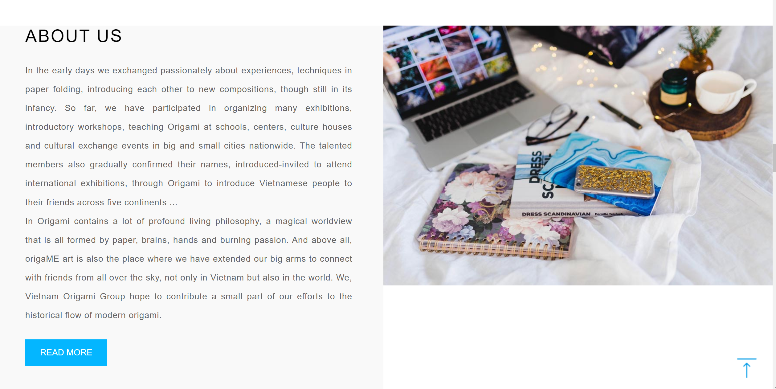

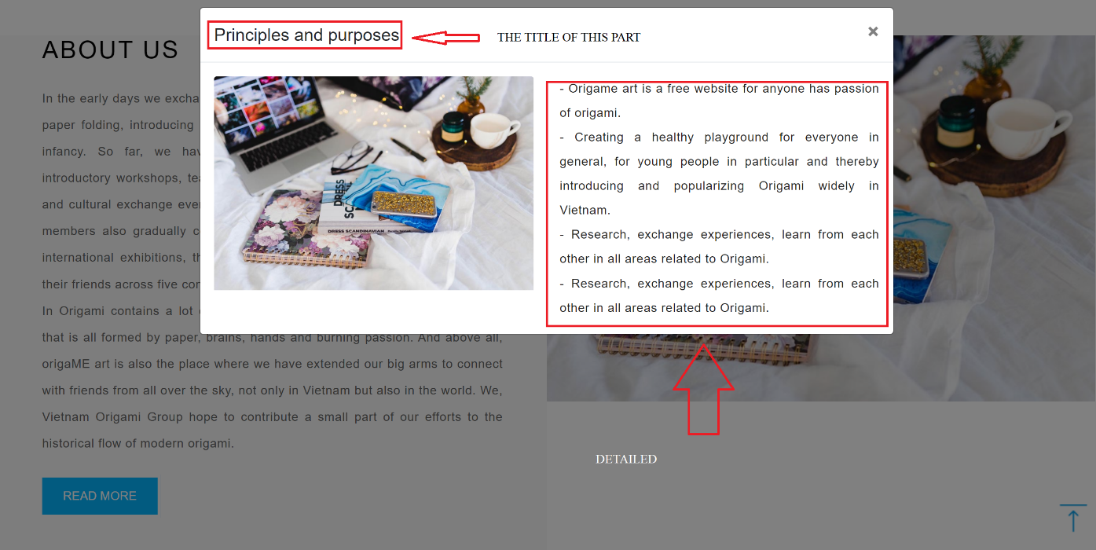

**MODELS**

**Description:**

In this models section, we talk about origami images from basic to advanced. In models, we divide it into different components like animals, action, modular, decorate.

When clicking on an object that you want to fold paper, it will appear a link to youtube describing how to fold.

**Screenshot**

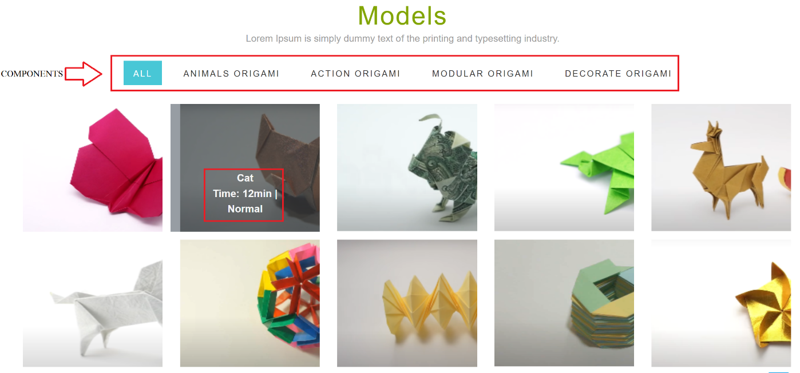

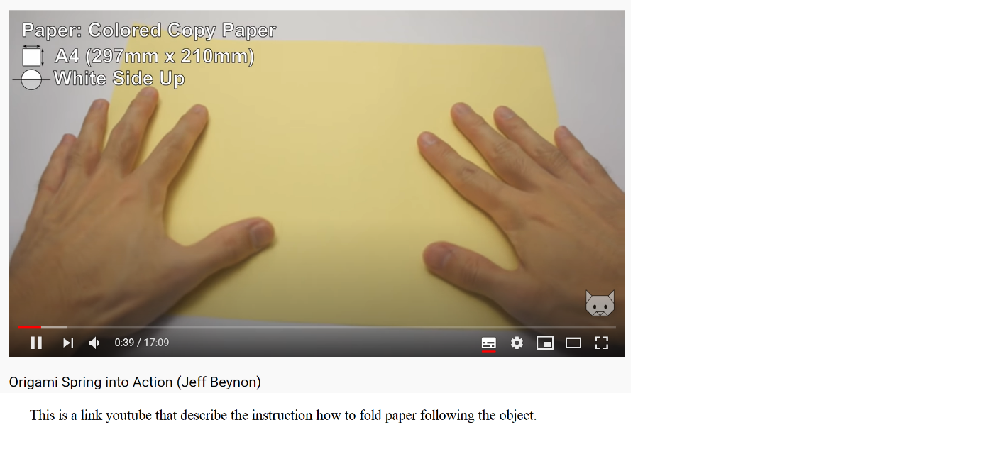

As you can see, when you click on the object that you really want to do, it will appear the link youtube how to fold the paper like that.

**NEWS**

**Description:**

In this section, the news is about the latest news of origami, such as the application of paper folding in human life, or the influence of the human spirit.

**Screenshot**

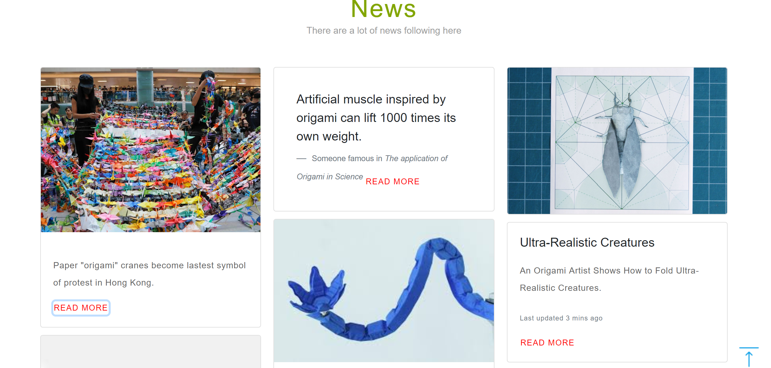

When you click READ MORE, it will displayed information about the news.

``````````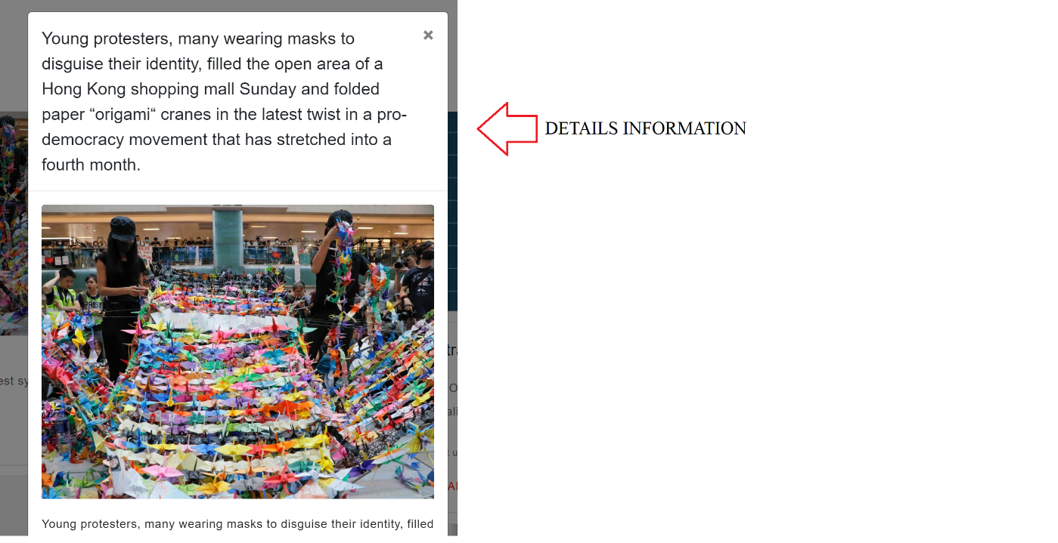

**ANOTHER PART:**

**Description:**

Also, we create the forms that describe information about our teams and the ways of creating origami by ourself. Finally, we have the motivation sentence to encourage your passion about making your origami object.

**Screenshot:**

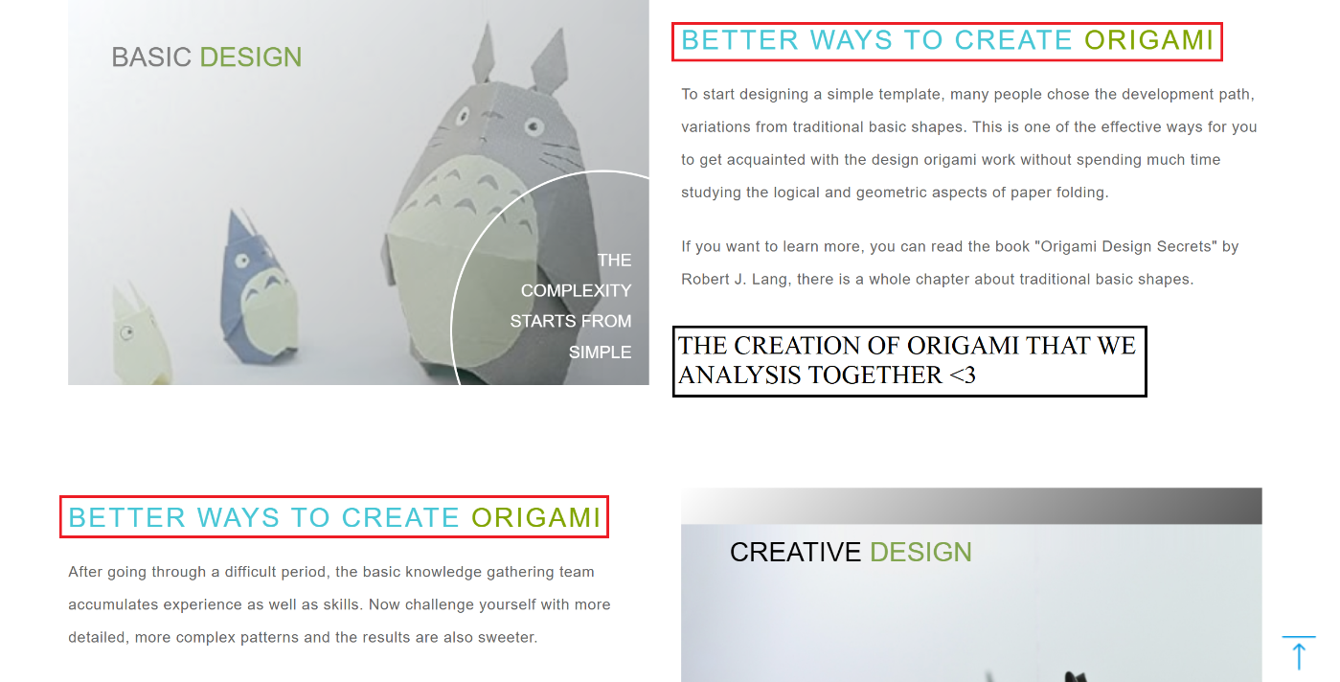

**THE MOTIVATION**

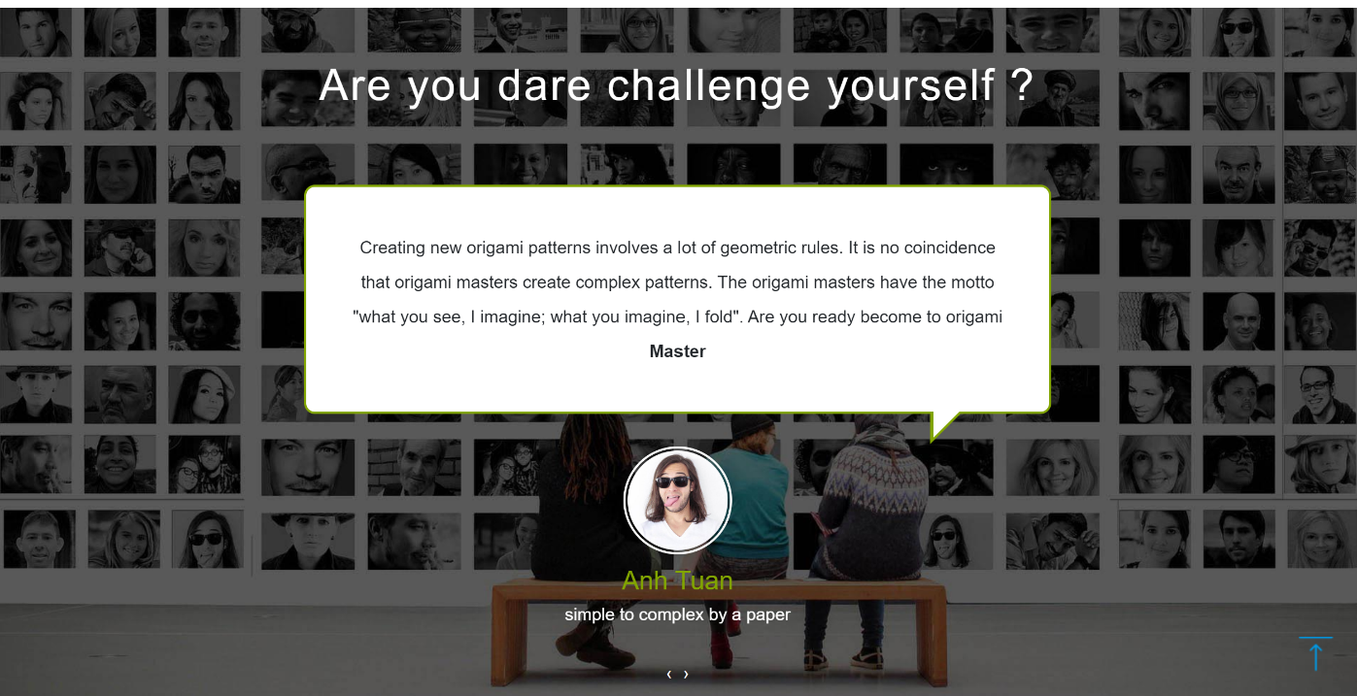

**CONTACT US:**

**Description:**

This webpage allows users to attend to contact with our team. In this part, we have the destination that we are working on and our phone numbers.

**Screenshot**

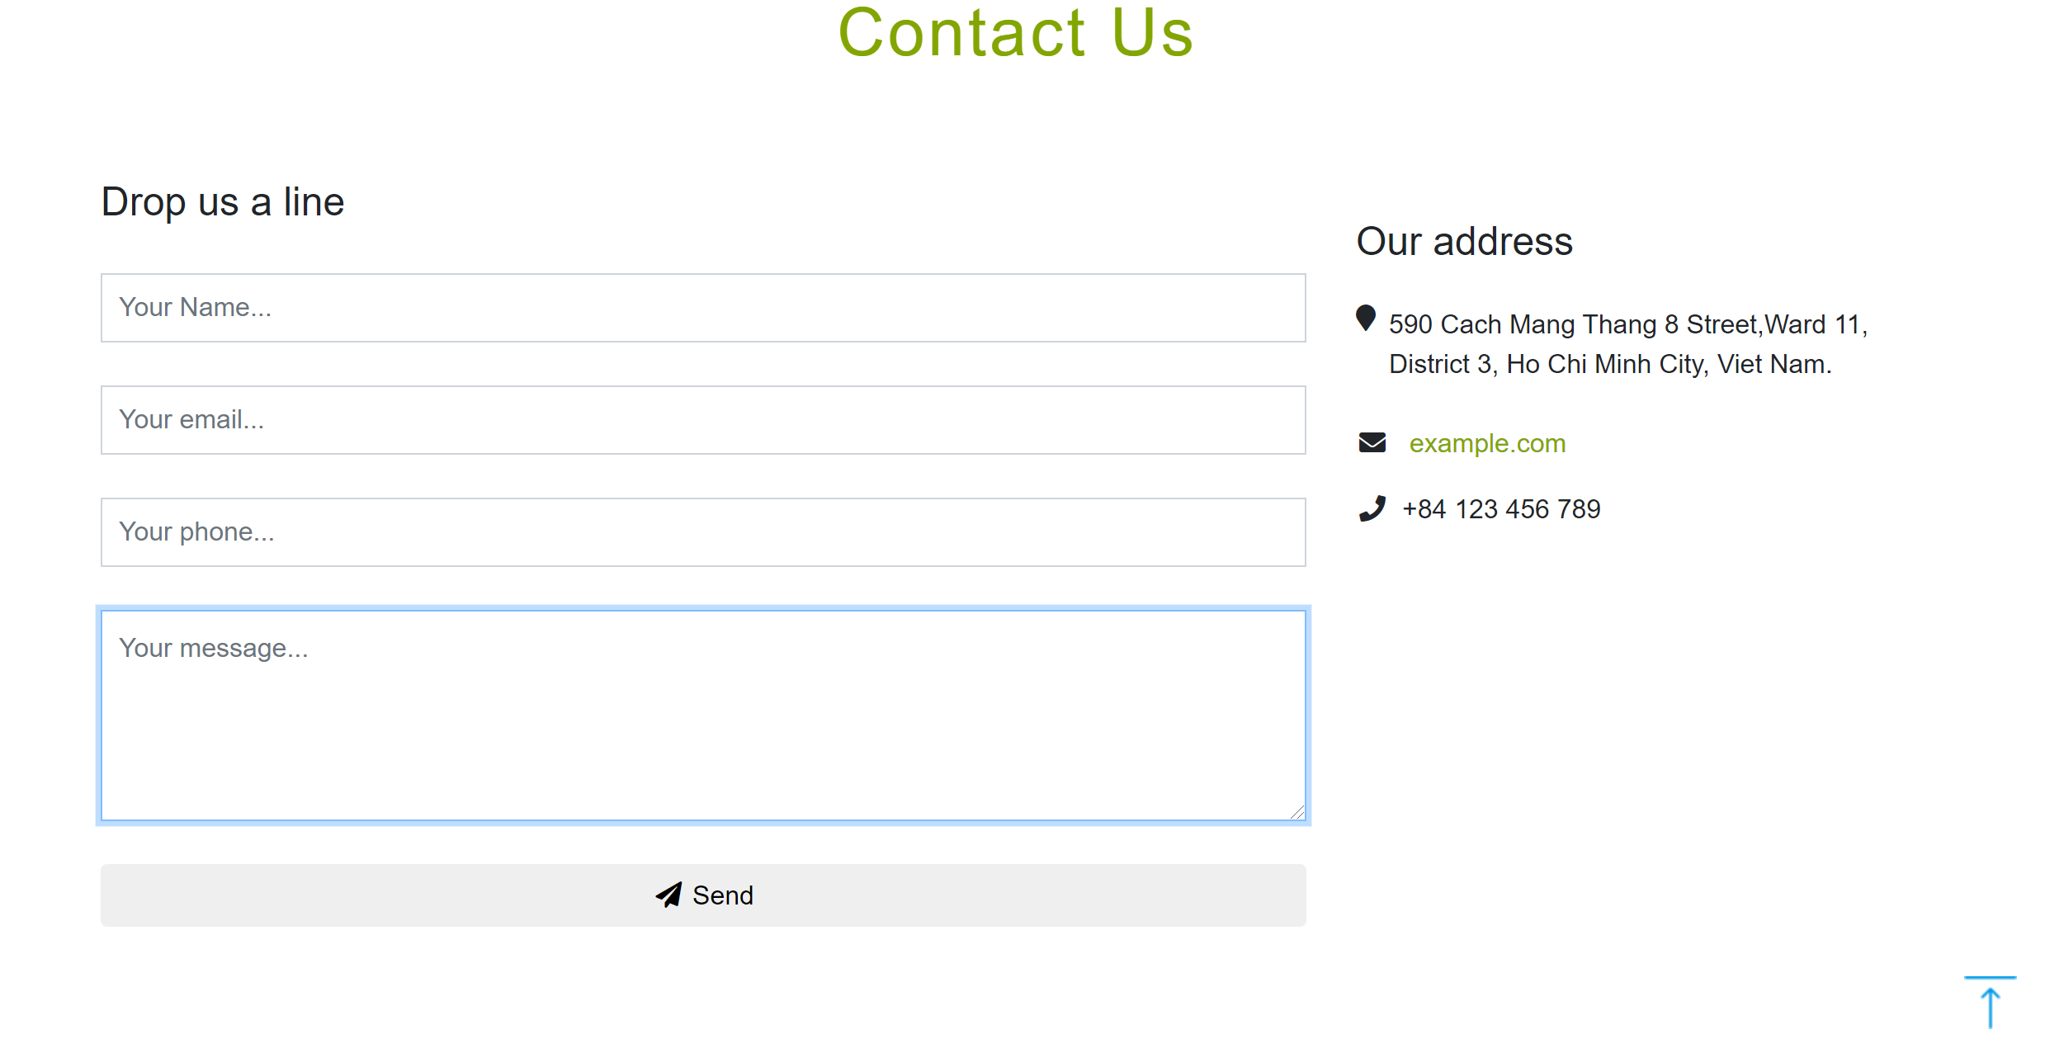

The users can fill up the form and contact with us like this.

**OUR GREAT TEAM**

**Description:**

This is our team members, we have 3 members in our team including: Nguyen Anh Tuan – designer, Doan Nguyen Tuan Anh – developer and Nguyen Kim Hoang Nam – marketing. Everyone in my team have the important role to contribute and finishing to build the e-project. Also, if you guys want to contact each our members, you can access the following links on each of categories: Facebook, Twitter and Gmail.

**Screenshot:**

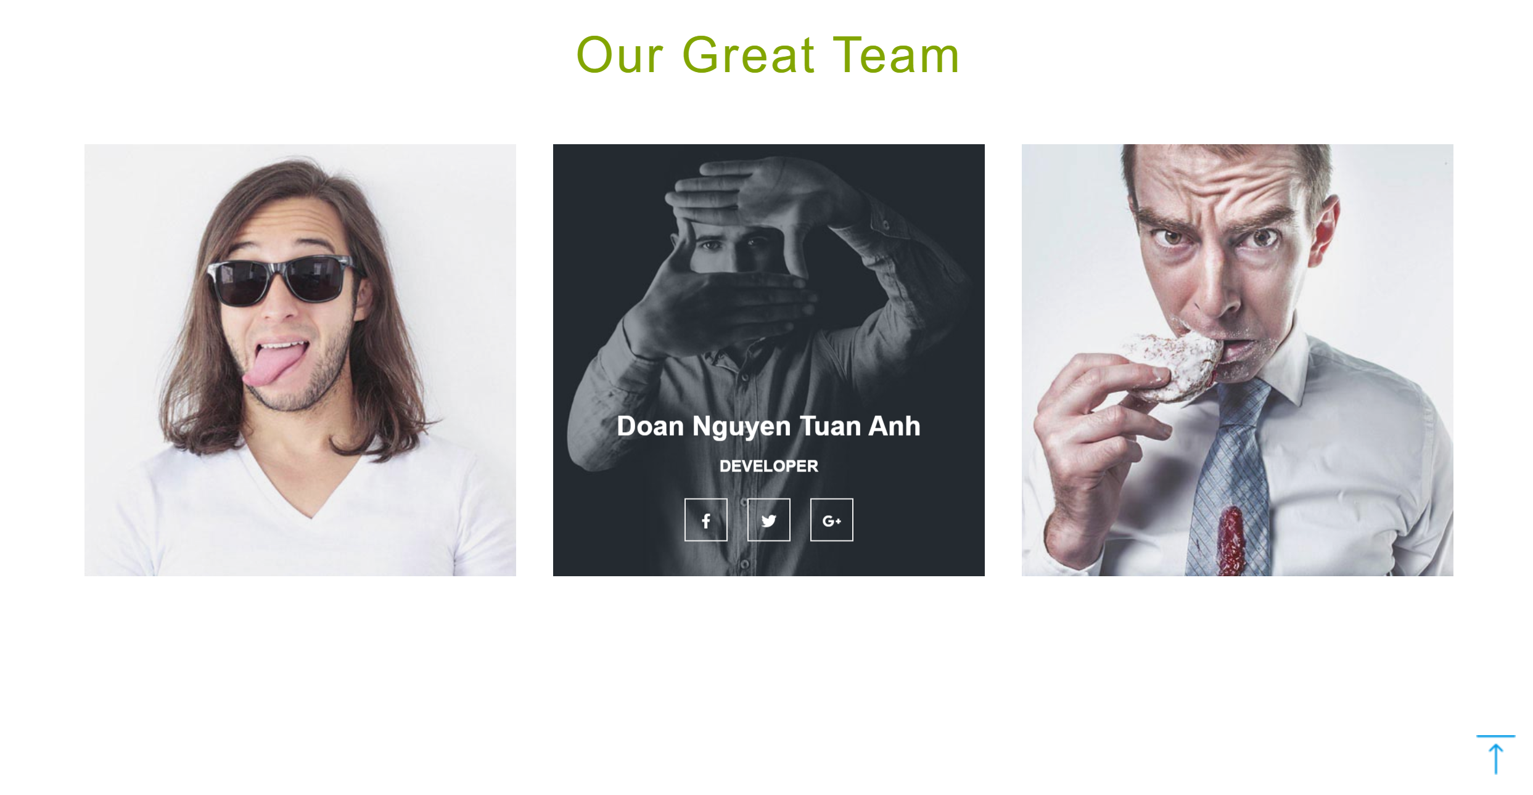

## TASK SHEET REVIEW 3

|  |  |  |  |  |  |  |  |  |
| --- | --- | --- | --- | --- | --- | --- | --- | --- |
| **Project Ref. No.: eProject / Askme**  **Mobile / 01** | | **Project Title:** | **Activity Plan**  **Prepare d By:** | **Date of Preparation of Activity Plan:** | | | | |
| **Sr. No.** | **Task** | **Actual Start Date** | | **Actual**  **Days** | **Team**  **Mate**  **Names** | **Status** |
| 1 | Home page | Origami  For  All | Nguyen  Anh  Tuan | 17-Jun-20 | | 2 | Anh  Tuan | Completed |
| 2 | Information | 17-Jun-20 | | 2 | Tuan  Anh | Completed |
| 3 | About | 19-Jun-20 | | 2 | Anh  Tuan | Completed |
| 4 | Models | 17-Jun-20 | | 10 | Hoang  Nam | Completed |
| 5 | News | 20-Jun-20 | | 3 | Tuan  Anh | Completed |
| 6 | Contact | 20-Jun-20 | | 1 | Anh  Tuan | Completed |
| 7 | Web description |  |  | 07-July-20 | | 1 | Tuan  Anh | Completed |
| 8 | User guide |  |  | 10-July-20 | | 1 | Anh  Tuan | Completed |
| **Date:** | | | | |  | | | |
| Signature of Instructor:            **Ms.Le Mong Thuy** | | | | | Signature of team leader:            **Mr.Nguyen Anh Tuan** | | | |